School Behaviour Support and Management Plan 2024

Spring Ridge Public School is committed to explicitly teaching and modelling positive behaviour and to supporting all students to be engaged with their learning. We endeavour to support and promote positive and respectful student behaviour through an evidence-informed positive behaviour support approach across the care continuum (see below).

Care Continuum

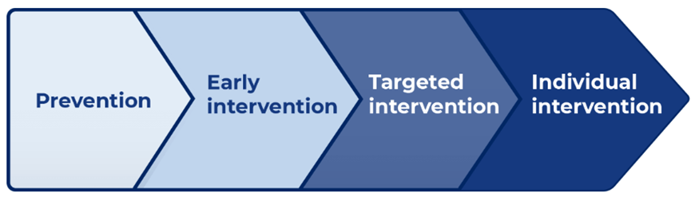

Partnership with Parents and Carers

Parents and carers have an important role in supporting student learning and positive behaviour. Spring Ridge Public School will partner with parents/carers in establishing expectations for parent engagement in developing and implementing student behaviour management strategies by regular communication between the school and parents and carers and through the school’s P&C.

Spring Ridge Public School will communicate these expectations to parents/carers by regular communication through the school’s newsletter, social media, meetings and discussions.

**Whole School Approach**

|  |  |  |  |
| --- | --- | --- | --- |
| **Care Continuum** | **Strategies** | **Details** | **Audience** |
| Prevention  Early Intervention | Positive Wellbeing Culture  High Expectations | * Strong teacher student relationships * Explicit teaching and modelling of specific skills including behaviour expectations and social skills * Class based systems of expectations and positive reinforcement * Consistent teacher expectations, routines, modelling, and responses to behaviour * Engaging parent involvement | All students |
| Early Intervention | Positive Wellbeing Culture:  Grow Your Mind | * Staff receive professional learning in building a positive wellbeing culture through the implementation of the Grow Your Mind Program. * Teachers will integrate mindfulness, movement breaks and social/emotional learning into teaching and learning programs | Individual students  Staff |
| Targeted Intervention | Personalised Learning Plans | * Teachers, students and families will work together to support those students who require personalised learning and support. Including instructional leadership, development of risk assessments and the development of short- and long-term goals | Individual students, families, and staff |
| Individual Intervention | Behaviour Management Plans | Development of a planned set of strategies that meet individual needs to support positive behaviour. | Individual students, families  Principal |

High expectations for student behaviour are established and maintained through effective role modelling, explicit teaching and planned responses.

The Behaviour Code for Students is communicated to students, staff, and families at regular times during the year including:

* In the school newsletter and social media
* In discussion with individual students and their families
* When a student is facing possible or actual suspension

**Buddy Time, Reflection Room and Restorative Practices**

For students requiring extra support or redirection of their behaviour the following strategies will be used:

**Buddy Room -** students will be sent to a neighbouring class to spend a short amount of time sitting down in a quiet part of the room.

This goal is to give the students a chance to calm and feel more ready to participate in class activities and learning.

**Reflection Room** -

- location in the 3/4/5/6 room during Recess or lunch break (depending on time of day)

- Students can eat and drink during their time in reflection room.

- Students can use the toilet during their time in the reflection.

- Students will complete a self-reflection sheet. This will be discussed to identify potential changes in behaviour, reactions, and strategies.

**Data Collection and Record Keeping**

Staff will enter details of negative behaviour and/or concerns of behaviour into reflection room book which is in the school’s office.

**Spring Ridge Public School’s Anti Bullying Plan**

Spring Ridge Public School’s Anti Bullying plan can be found on the school’s webpage.

**Responses to serious behaviours of concern**

* review and document incident
* detention, reflection and restorative practices (listed above)
* formal caution to suspend, suspension or expulsion.

The NSW Department of Education Student Behaviour policy and Suspension and Expulsion Procedures apply to all NSW public schools.

**Reporting and recording behaviours of concern**

Staff will comply with reporting and responding processes outlined in the:

* Incident Notification and Response Policy
* Incident Notification and Response Procedures
* Student Behaviour policy and Suspension and Expulsion procedures.

Review dates

Last review date: 31/01/2025): Day 1, Term 1, 2025

Next review date: 27/01/2026: Day 1, Term 1, 2026